WEEK - 5
TASK 1 :
AIM :
To find the maximum sum of a contiguous subarray in a given integer array.
ALGORITHM:
- Initialize two variables maxSoFar and currentMax with the first element of the array.
- Traverse the array from the second element to the end.
- For each element, calculate the maximum of:
  - The current element alone, or
  - The sum of the current element and currentMax.
- Update maxSoFar with the maximum of maxSoFar and currentMax.
- Continue until all elements are processed.
- Return maxSoFar as the maximum subarray sum.
PROGRAM :
class Solution {
public int maxSubArray(int[] nums) {
int maxSoFar = nums[0];
int currentMax = nums[0];
for (int i = 1; i < nums.length; i++) {
currentMax = Math.max(nums[i], currentMax + nums[i]);
maxSoFar = Math.max(maxSoFar, currentMax);
}
return maxSoFar;
}
}

OUTPUT :

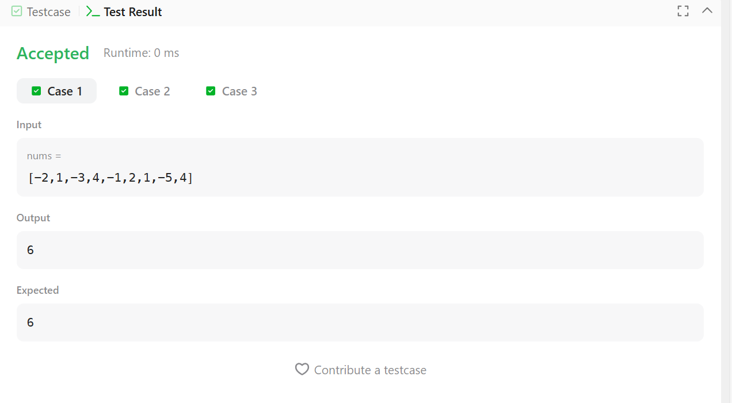

RESULT :
The program successfully finds and returns the maximum sum of any contiguous subarray in the given array.

TASK 2 :
AIM :
To find the number of contiguous segments of length m in a list whose sum equals the given value d.
ALGORITHM:
- Read the number of elements and store them in a list.
- Read the values d (desired sum) and m (segment length).
- Initialize a variable count to 0.
- Traverse the list from index 0 to size - m.
- For each position, calculate the sum of the next m elements.
- If the calculated sum equals d, increment count.
- After checking all possible segments, return count.
PROGRAM :
import java.util.*;
class Solution {
public static int birthday(List<Integer> s, int d, int m) {
int count = 0;
for (int i = 0; i <= s.size() - m; i++) {
int sum = 0;
for (int j = 0; j < m; j++) {
sum += s.get(i + j);
}
if (sum == d) {
count++;
}

}
return count;
}
public static void main(String[] args) {
Scanner sc = new Scanner(System.in);

int n = sc.nextInt();
List<Integer> s = new ArrayList<>();
for (int i = 0; i < n; i++) {
s.add(sc.nextInt());
}

int d = sc.nextInt();
int m = sc.nextInt();

System.out.println(birthday(s, d, m));

sc.close();
}
}

OUTPUT :
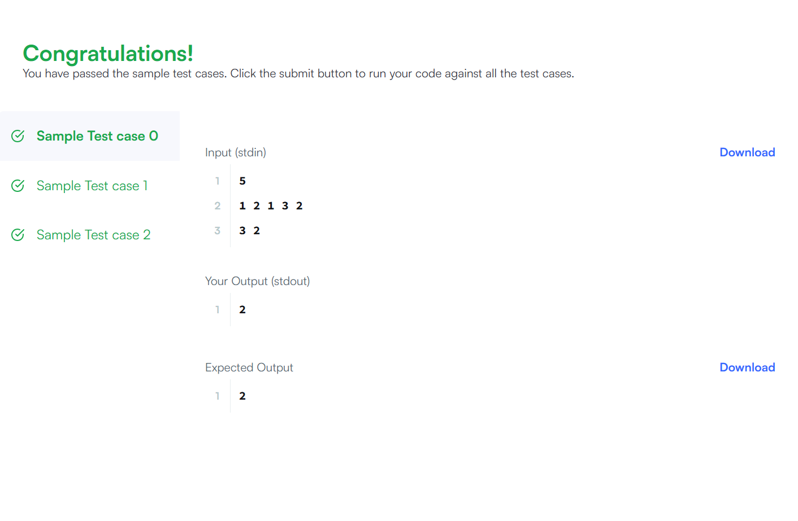
RESULT:
The program successfully counts and displays the number of contiguous segments of length m whose sum equals the given value d.

TASK 3 :
AIM :
To find the maximum subarray sum (contiguous elements) and maximum subsequence sum (non-contiguous elements) from a given array.
ALGORITHM:
- Read the number of test cases and array elements.
- For maximum subarray sum:
  - Initialize currentMax and maxSubarray with the first element.
  - Traverse the array from the second element.
  - Update currentMax as the maximum of current element or sum of current element and previous currentMax.
  - Update maxSubarray with the maximum value.
- For maximum subsequence sum:
  - Initialize maxSubsequence as 0.
  - Add all positive elements in the array.
  - If no positive element exists, take the maximum element in the array.
- Return both results.
- Print the maximum subarray and maximum subsequence sums.

PROGRAM :
import java.util.*;
class Solution {
public static int[] maxSubarray(int[] arr) {
int maxSubarray = arr[0];
int currentMax = arr[0];
for (int i = 1; i < arr.length; i++) {
currentMax = Math.max(arr[i], currentMax + arr[i]);
maxSubarray = Math.max(maxSubarray, currentMax);
}
int maxSubsequence = 0;
boolean hasPositive = false;
for (int num : arr) {
if (num > 0) {
maxSubsequence += num;
hasPositive = true;
}
}
if (!hasPositive) {
maxSubsequence = Arrays.stream(arr).max().getAsInt();
}

return new int[]{maxSubarray, maxSubsequence};
}
public static void main(String[] args) {
Scanner sc = new Scanner(System.in);
int t = sc.nextInt();
while (t-- > 0) {

int n = sc.nextInt();
int[] arr = new int[n];
for (int i = 0; i < n; i++) {
arr[i] = sc.nextInt();
}
int[] result = maxSubarray(arr);
System.out.println(result[0] + " " + result[1]);
}
sc.close();
}
}

OUTPUT :
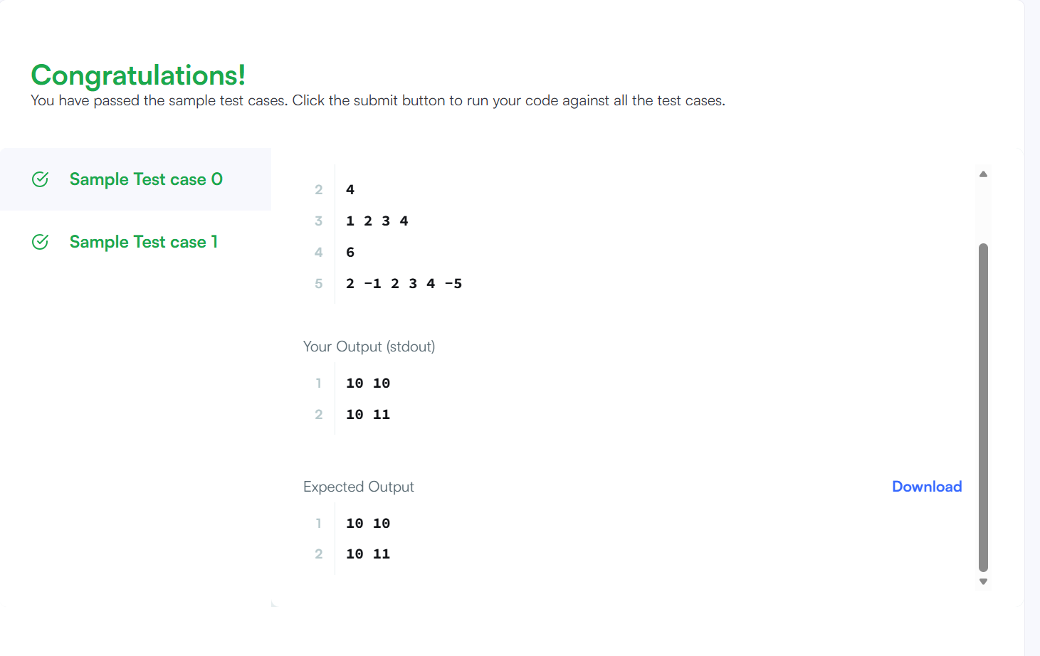
RESULT:
The program successfully calculates and prints the maximum contiguous subarray sum and the maximum non-contiguous subsequence sum for each test case.

TASK 4 :
AIM :
To find the maximum sum of a circular subarray in a given integer array.
ALGORITHM:
- Initialize variables totalSum, maxSum, curMax, minSum, and curMin.
- Traverse each element in the array.
- Update curMax as the maximum of current element or sum of current element and curMax.
- Update maxSum with the maximum value found so far.
- Update curMin as the minimum of current element or sum of current element and curMin.
- Update minSum with the minimum value found so far.
- Add each element to totalSum.
- If all elements are negative, return maxSum.
- Otherwise, return the maximum of maxSum and (totalSum - minSum).
PROGRAM :
import java.util.*;
class Solution {
public int maxSubarraySumCircular(int[] nums) {
int totalSum = 0;
int maxSum = nums[0], curMax = 0;
int minSum = nums[0], curMin = 0;
for (int num : nums) {
curMax = Math.max(curMax + num, num);
maxSum = Math.max(maxSum, curMax);
curMin = Math.min(curMin + num, num);

minSum = Math.min(minSum, curMin);
totalSum += num;
}
if (maxSum < 0) return maxSum;
return Math.max(maxSum, totalSum - minSum);
}
public static void main(String[] args) {
Scanner sc = new Scanner(System.in);
System.out.println("Enter array length:");
int n = sc.nextInt();
int[] nums = new int[n];
System.out.println("Enter array elements:");
for (int i = 0; i < n; i++) {
nums[i] = sc.nextInt();
}
Solution sol = new Solution();
int result = sol.maxSubarraySumCircular(nums);
System.out.println("Maximum circular subarray sum: " + result);
sc.close();
}
}

OUTPUT :
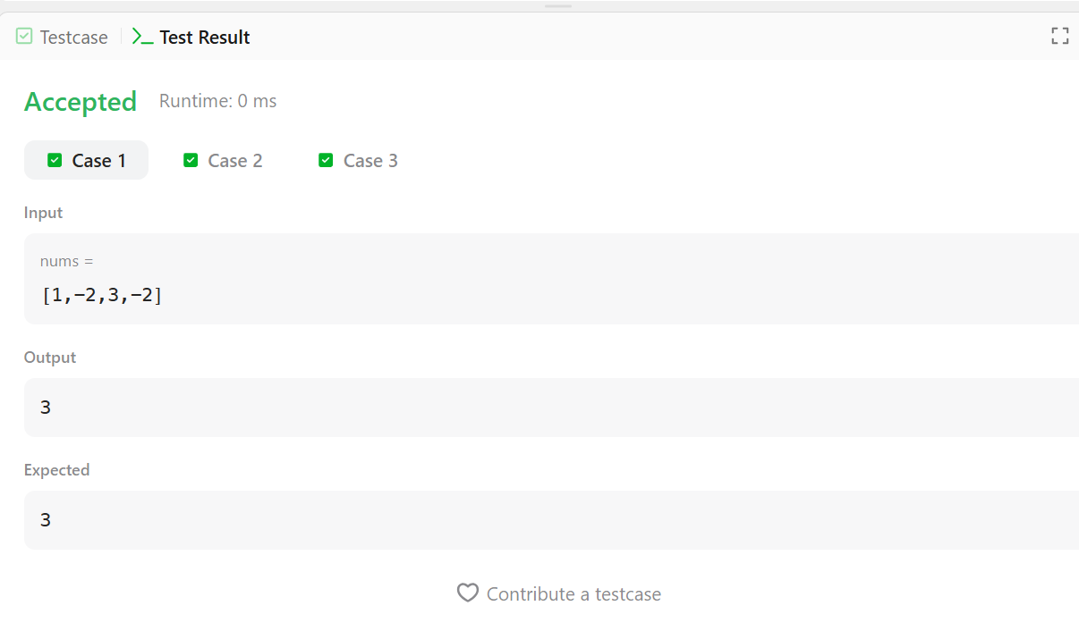
RESULT:
The program successfully calculates and displays the maximum possible sum of a circular subarray from the given array.

TASK -5
AIM :
To find the maximum sum of a circular subarray in a given integer array.
ALGORITHM:
- Initialize variables totalSum, maxSum, curMax, minSum, and curMin.
- Traverse each element in the array.
- Update curMax as the maximum of current element or sum of current element and curMax.
- Update maxSum with the maximum value found so far.
- Update curMin as the minimum of current element or sum of current element and curMin.
- Update minSum with the minimum value found so far.
- Add each element to totalSum.
- If all elements are negative, return maxSum.
- Otherwise, return the maximum of maxSum and (totalSum - minSum).
PROGRAM :
class Solution {
public int myAtoi(String s) {
if (s == null || s.length() == 0) return 0;
int i = 0, n = s.length();
while (i < n && s.charAt(i) == ' ') {
i++;
}
int sign = 1;
if (i < n && (s.charAt(i) == '+' || s.charAt(i) == '-')) {
sign = (s.charAt(i) == '-') ? -1 : 1;
i++;
}

long result = 0;
while (i < n && Character.isDigit(s.charAt(i))) {
int digit = s.charAt(i) - '0';
result = result * 10 + digit;
if (sign == 1 && result > Integer.MAX_VALUE) {
return Integer.MAX_VALUE;
}
if (sign == -1 && -result < Integer.MIN_VALUE) {
return Integer.MIN_VALUE;
}
i++;
}

return (int) (sign * result);
}
}

OUTPUT :
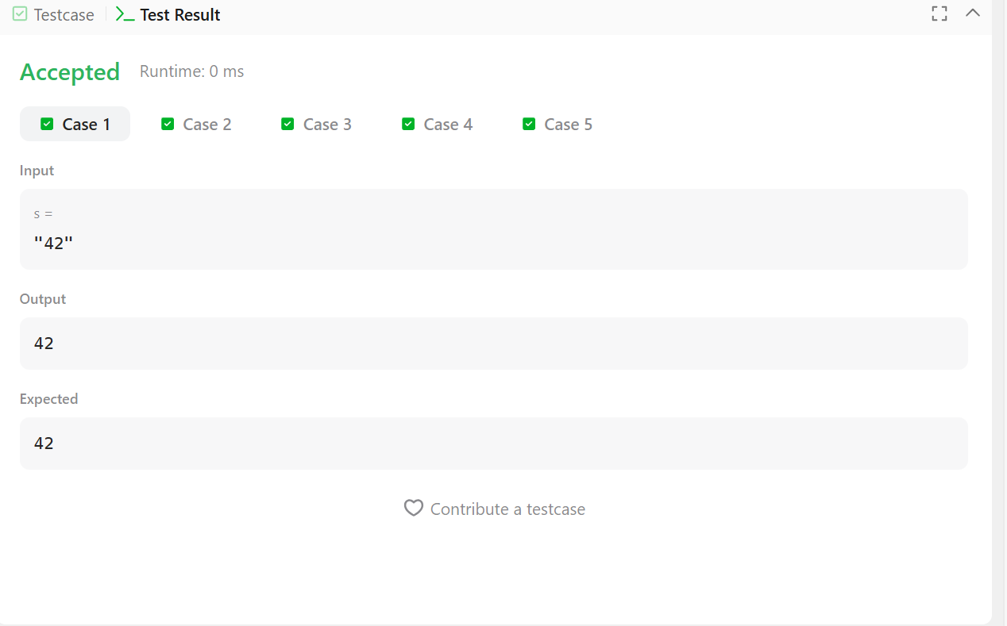

RESULT :
The program successfully calculates and displays the maximum possible sum of a circular subarray from the given array.

TASK 6 :
AIM :
To convert a given string into a 32-bit signed integer following the rules of the atoi function.
ALGORITHM:
- Check if the string is null or empty; if yes, return 0.
- Skip all leading whitespace characters.
- Check for an optional sign (+ or -) and set the sign accordingly.
- Initialize a variable result to store the numeric value.
- Traverse the string while characters are digits:
  - Convert each character into its numeric value.
  - Update result = result × 10 + digit.
  - If overflow occurs, return Integer.MAX_VALUE or Integer.MIN_VALUE accordingly.
- Multiply the result with the sign.
- Return the final integer value.
PROGRAM :
import java.util.*;
public class Solution {
public static int alternatingCharacters(String s) {
int deletions = 0;
for (int i = 1; i < s.length(); i++) {
if (s.charAt(i) == s.charAt(i - 1)) {
deletions++;
}
}

return deletions;
}
public static void main(String[] args) {
Scanner sc = new Scanner(System.in);
int q = sc.nextInt();
sc.nextLine(); // consume newline
for (int i = 0; i < q; i++) {
String s = sc.nextLine();
System.out.println(alternatingCharacters(s));
}
sc.close();
}
}

OUTPUT:
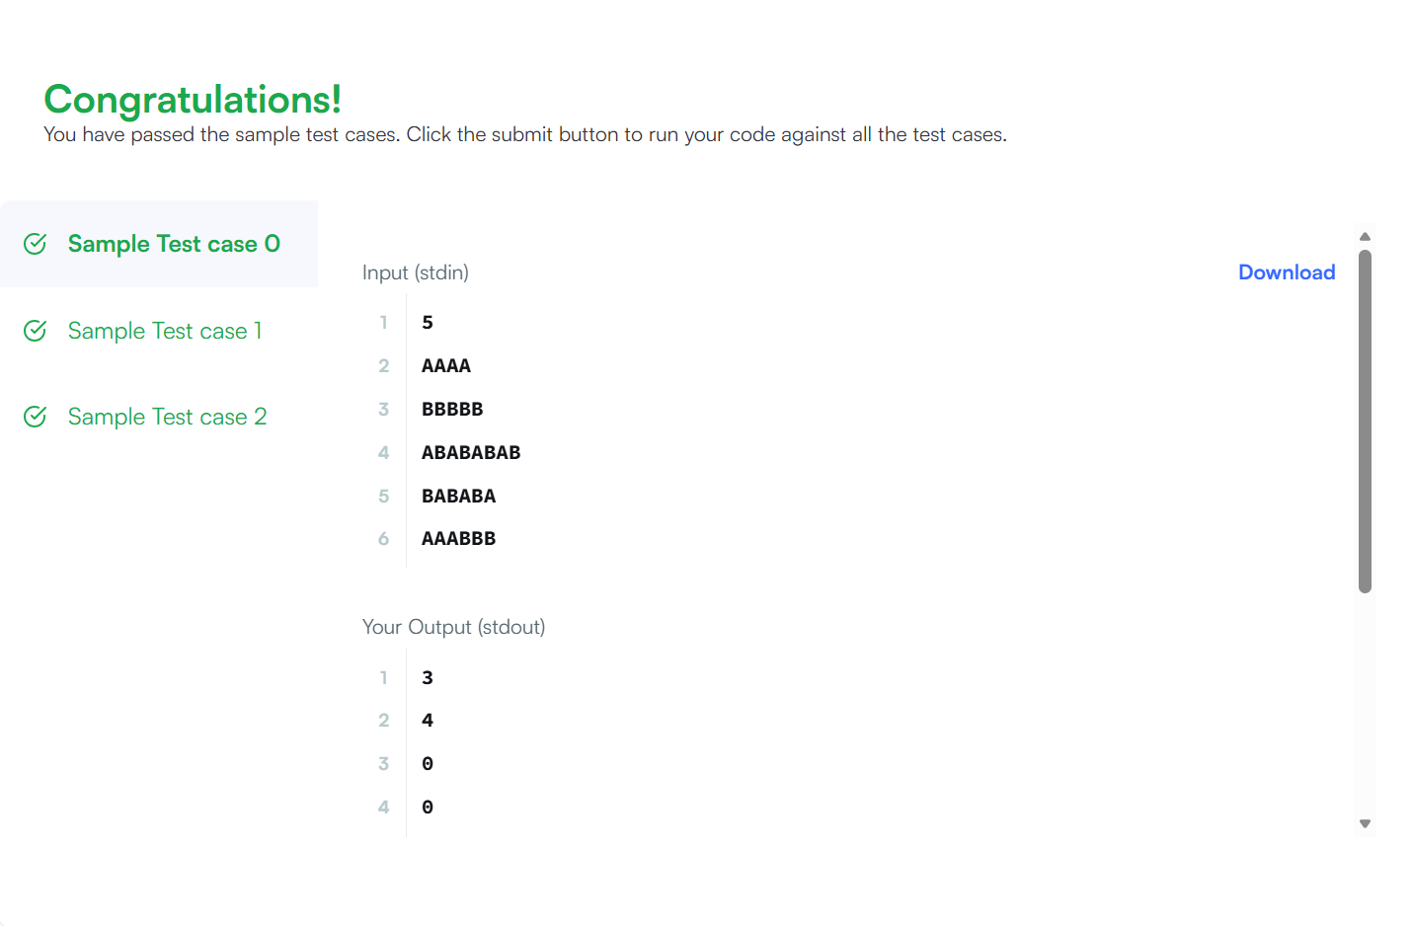

RESULT :
The program successfully converts the given string into a valid 32-bit signed integer while handling whitespace, sign, invalid characters, and overflow conditions correctly.

TASK - 9 :
AIM :
To find the length of the longest substring in a given string without repeating characters.
ALGORITHM:
- Create an empty set to store unique characters.
- Initialize two pointers left = 0 and max = 0.
- Traverse the string using pointer right.
- If the current character already exists in the set, remove characters from the left side until it becomes unique.
- Add the current character to the set.
- Update max with the maximum value of the current substring length (right - left + 1).
- Continue until the end of the string.
- Return max.

PROGRAM :
import java.util.*;
class Solution {
public int lengthOfLongestSubstring(String s) {
Set<Character> set = new HashSet<>();
int left = 0, max = 0;
for (int right = 0; right < s.length(); right++) {
while (set.contains(s.charAt(right))) {
set.remove(s.charAt(left++));
}
set.add(s.charAt(right));
max = Math.max(max, right - left + 1);

}
return max;
}
}

OUTPUT :
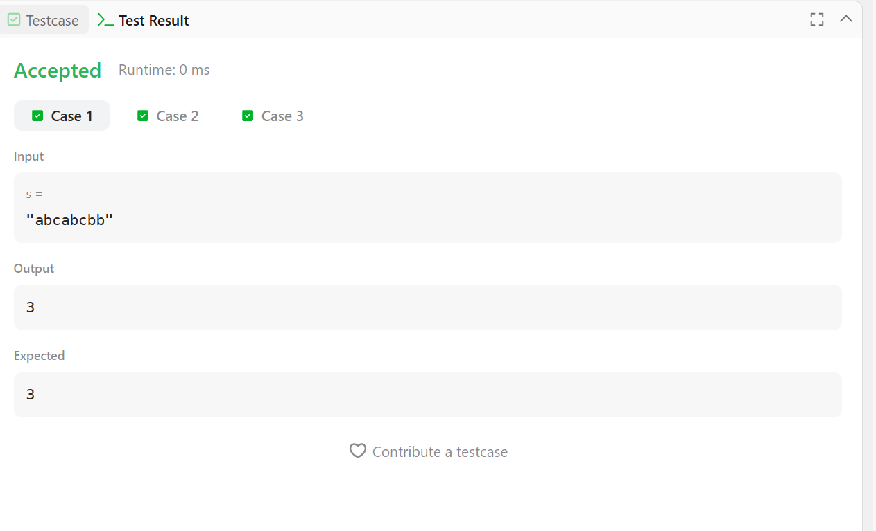
RESULT :
The program successfully calculates and returns the length of the longest substring without repeating characters in the given string.

TASK – 8
AIM :
To find all words from the given list that match a specific pattern using a one-to-one character mapping.
ALGORITHM:
- Read the list of words and the given pattern.
- Create an empty list to store matching words.
- For each word in the list:
  - Check if the word length is equal to the pattern length.
- Create two hash maps to store character mappings between pattern and word.
- Traverse each character of the word and pattern:
  - If a mapping already exists and does not match, return false.
  - Otherwise store the mapping in both maps.
- If all characters follow the mapping correctly, add the word to the result list.
- Return the list of matching words.
PROGRAM :
import java.util.*;
class Solution {
public List<String> findAndReplacePattern(String[] words, String pattern) {
List<String> result = new ArrayList<>();

for (String word : words) {
if (matches(word, pattern)) {
result.add(word);
}
}

return result;
}

private boolean matches(String word, String pattern) {
if (word.length() != pattern.length()) return false;

Map<Character, Character> map1 = new HashMap<>();
Map<Character, Character> map2 = new HashMap<>();

for (int i = 0; i < word.length(); i++) {
char w = word.charAt(i);
char p = pattern.charAt(i);

if (map1.containsKey(p) && map1.get(p) != w)
return false;

if (map2.containsKey(w) && map2.get(w) != p)
return false;

map1.put(p, w);
map2.put(w, p);
}

return true;
}
}

OUTPUT :

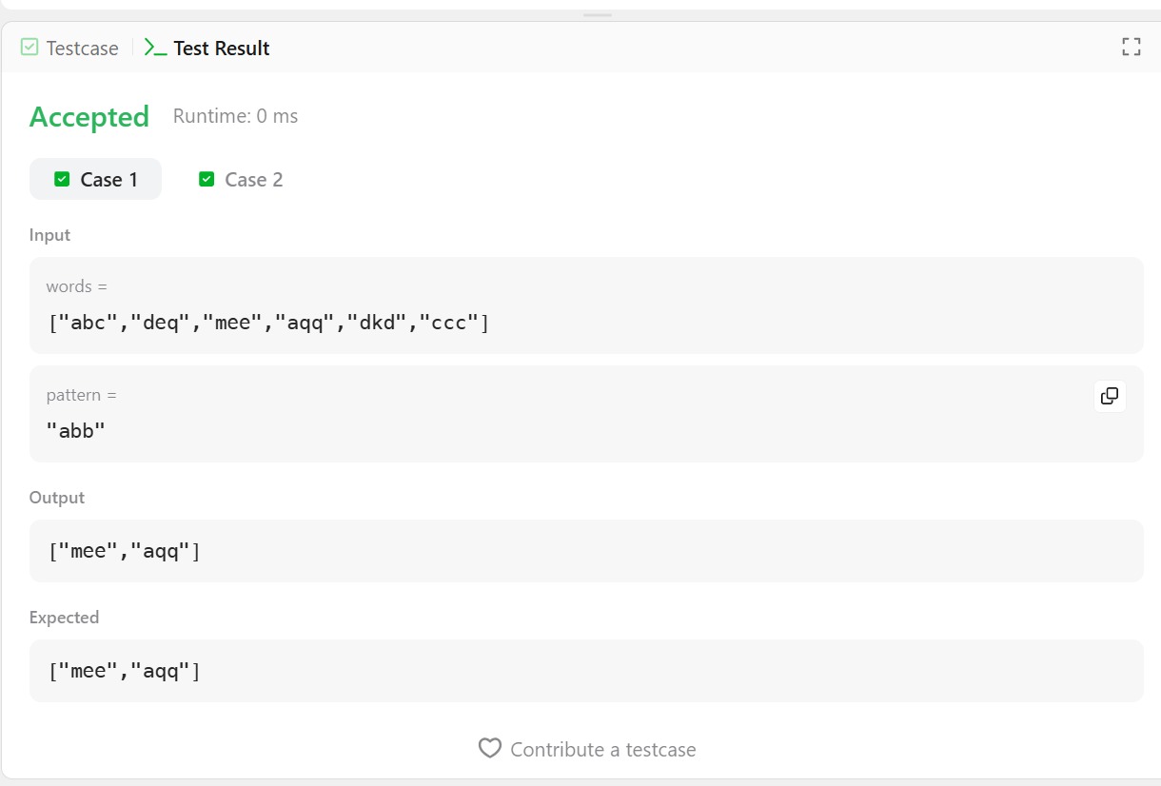

RESULT :
The program successfully identifies and returns all words that follow the same character pattern as the given pattern string.

TASK – 9
AIM :
To find all strings in a given array that are substrings of another string in the same array.
ALGORITHM:
- Read the array of strings.
- Create an empty list to store the result.
- Use two loops to compare each word with every other word in the array.
- For each pair of words, check if one word is contained in the other using the contains() method.
- Ensure the indices of the two words are not the same.
- If a word is found as a substring of another word, add it to the result list.
- Break the inner loop to avoid duplicate additions.
- Return the list containing all substring words.

PROGRAM :
import java.util.*;
class Solution {
public List<String> stringMatching(String[] words) {
List<String> result = new ArrayList<>();
for (int i = 0; i < words.length; i++) {
for (int j = 0; j < words.length; j++) {
if (i != j && words[j].contains(words[i])) {
result.add(words[i]);
break;
}
}
}

return result;
}
public static void main(String[] args) {
Solution sol = new Solution();
String[] words1 = {"mass","as","hero","superhero"};
System.out.println(sol.stringMatching(words1));
String[] words2 = {"leetcode","et","code"};
System.out.println(sol.stringMatching(words2));
String[] words3 = {"blue","green","bu"};
System.out.println(sol.stringMatching(words3));
}
}

OUTPUT :
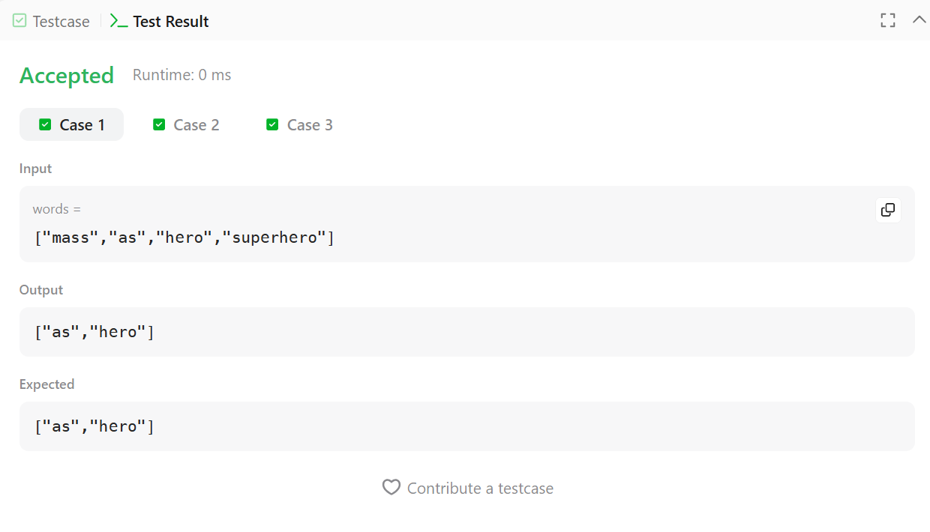
RESULT :
The program successfully identifies and prints all words that appear as substrings of another word in the given array.

